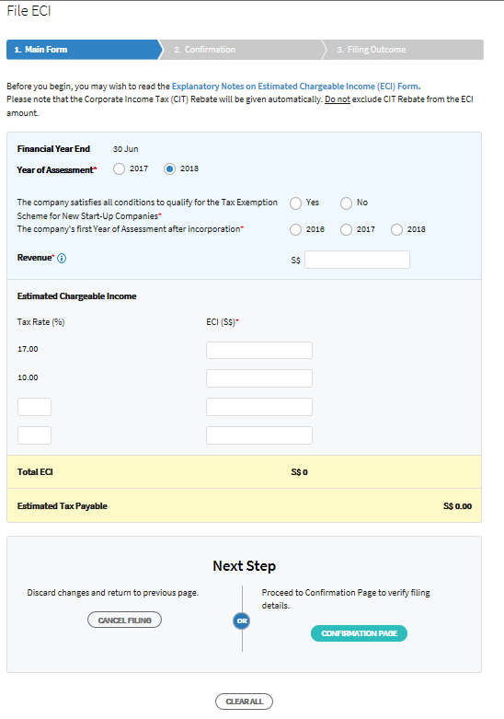

First Page of ECI Filing (Main Form)

Screen Fields

| Field | Type | Mandatory | Details |
| --- | --- | --- | --- |
| Explanatory Notes on Estimated Chargeable Income (ECI) | Hyperlink |  | To download the Explanatory Notes on ECI pdf file.  https://www.iras.gov.sg/irashome/uploadedFiles/IRASHome/Quick_Links/Forms/Businesses/Corporate_Tax_forms/Explanatory%20notes%20for%20ECI.pdf |
| Financial Year End | Pre-filled field | Yes | Financial Year End of the organization as provided in corporate profile. |
| The company satisfies all conditions to qualify for the Tax Exemption Scheme for New Start-Up Companies. * | Radio button | Yes | Need to choose “Yes”, if the company declares that   1. it is incorporated in Singapore; 2. it is a tax resident of Singapore for Year of Assessment (YA) 2018; 3. it has no more than 20 shareholders throughout the basis period for YA 2018 4. all of whom are individuals beneficially and directly holding the shares in their own names; or 5. where there are non-individual shareholders, at least one shareholder is an individual beneficially and directly holding at least 10% of the issued ordinary shares of the company; 6. If it is incorporated after 25 Feb 2013, 7. its principal activity is not that of developing properties for sale, for investment, or for both investment and sale; and 8. its principal activity is not that of investment holding.   Unless need to choose “No”.  Validation:  Condition: If empty  Message : Required field |
| Year of Assessment* | Radio button | Yes | You can e-file for the current YA  and one advance YA.  Validation:  Condition: If empty  Message : Required field |
| The company’s first Year of Assessment after incorporation* | Radio button |  | If the company qualifies for Full Tax Exemption.  To indicate its first Year of Assessment (YA) upon incorporation.  Validation:  Condition: If empty  Message : Required field |
| Revenue | Textbox | Yes | Numeric whole number (without decimal) (length : 12)  Enter the Revenue amount. This field is compulsory.  iHelp Content:  “Revenue refers to a company’s main source of income, excluding separate source income such as interest.  For an investment holding company, it would be its investment income. (e.g. interest and dividend income).”  Validation:  Condition: If empty  Message : Enter Revenue amount |
| 3rd Tax Rate | Textbox | No | Not mandatory to enter.  If user enter the input, it should be numeric number between 0.00% and 10%  The textbox should be able to accept, display and process tax rate of up to 2 decimal places, e.g.0.30.  Validation:  Condition: < 0 and > 10%  Message: Invalid tax rate |
| 4th Tax Rate | Textbox | No | Not mandatory to enter.  If user enter the input, it should be numeric number between 0.00% and 10%  The textbox should be able to accept, display and process tax rate of up to 2 decimal places, e.g.0.30.  Validation:  Condition: < 0 and > 10%  Message: Invalid tax rate |
| ECI S$ @ 17% Tax Rate | Textbox |  | Numeric whole numbers (without decimals)  X (11)  Each ECI S$ is not mandatory if respective tax rate is not applicable, but at least one ECI S$ textbox need to be filled among the four ECI S$ textboxes.  Validation:  Condition: < 0  Message: ECI is less than 0 |
| ECI S$ @ 10% Tax Rate | Textbox |  | Numeric whole numbers (without decimals)  X (11)  Each ECI S$ is not mandatory if respective tax rate is not applicable, but at least one ECI S$ textbox need to be filled among the four ECI S$ textboxes.  Validation:  Condition: < 0  Message: ECI is less than 0 |
| ECI S$ @ 3rd Tax Rate | Textbox |  | Numeric whole numbers (without decimals)  X (11)  If 3rd Tax Rate is not entered, the textbox should not enter the text.  Each ECI S$ is not mandatory if respective tax rate is not applicable, but at least one ECI S$ textbox need to be filled among the four ECI S$ textboxes.  Validation:  Condition: < 0  Message: ECI is less than 0 |
| ECI S$ @ 4th Tax Rate | Textbox |  | Numeric whole numbers (without decimals)  X (11)  If 3rd Tax Rate is not entered, the textbox should not enter the text.  Each ECI S$ is not mandatory if respective tax rate is not applicable, but at least one ECI S$ textbox need to be filled among the four ECI S$ textboxes.  Validation:  Condition: < 0  Message: ECI is less than 0 |
| Total ECI | System computed |  | Numeric (length 12)  ECI S$ @ 17% Tax Rate + ECI S$ @ 10% Tax Rate + ECI S$ @ 3rd Tax Rate + ECI S$ @ 4th Tax Rate  e.g. $1,000 x 10% + $1,000 x 17% |
| Estimated Tax Payable | Entry Field System computed |  | Numeric (length 12)  Total ECI – CT Rebate %  CT Rebate % for YA 2017 is 50%  CT Rebate % for YA 2018 is 20%  e.g. $270 x 20% = $54  $270-54 = $216  Please see the Tax Calculation Tables below for detail |
| Cancel Filing | Button |  | System will bring user to Corporate Tax Landing page. |
| Confirmation Page | Button |  | Check the validation requirements and proceed to the confirmation page. |
| Clear All | Button |  | System will clear all the entry fields on the tax form. |

Tax Calculation Tables

YA 2017

|  |  |
| --- | --- |
| **Gross tax payable**  ($1000 x 10% + $1000 x 17%) | $270 |
| **Less: Corporate Income Tax Rebate**  ($270 x 50% = $135; restricted to cap of $10,000) | $54 |
| **Net tax payable** | **$135** |

YA 2018

|  |  |
| --- | --- |
| **Gross tax payable**  ($1000 x 10% + $1000 x 17%) | $270 |
| **Less: Corporate Income Tax Rebate**  ($270 x 20% = $54; restricted to cap of $10,000) | $54 |
| **Net tax payable** | **$216** |